CCNP ROUTING AND SWITCHING



AWS Load Balancing

B Brennen Tse . 3/1/2022

Creating an AMI for Web Server 1

Navigate to E2 in the services menu

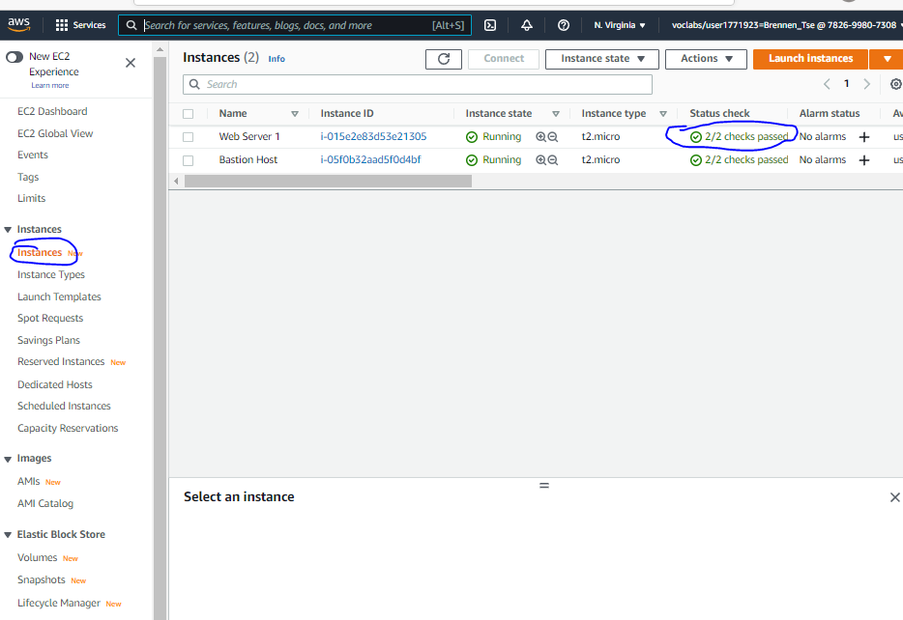

Confirm instance is running by clicking Instances in the left navigation pane, and checking that the 2/2 checks passed is seen in the status check area.

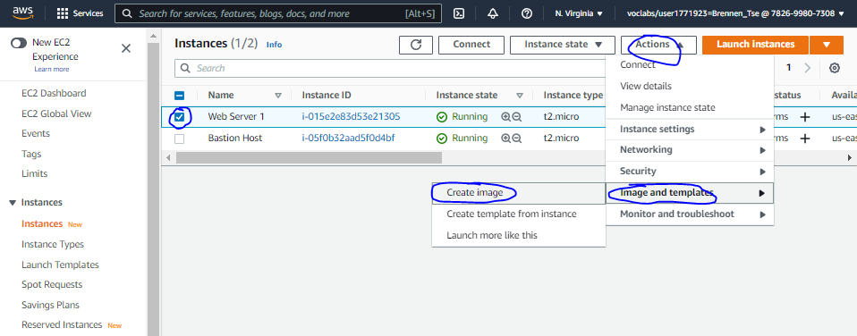1, check the box for webserver, then in the actions dropdown menu, select image and templates and create an image.

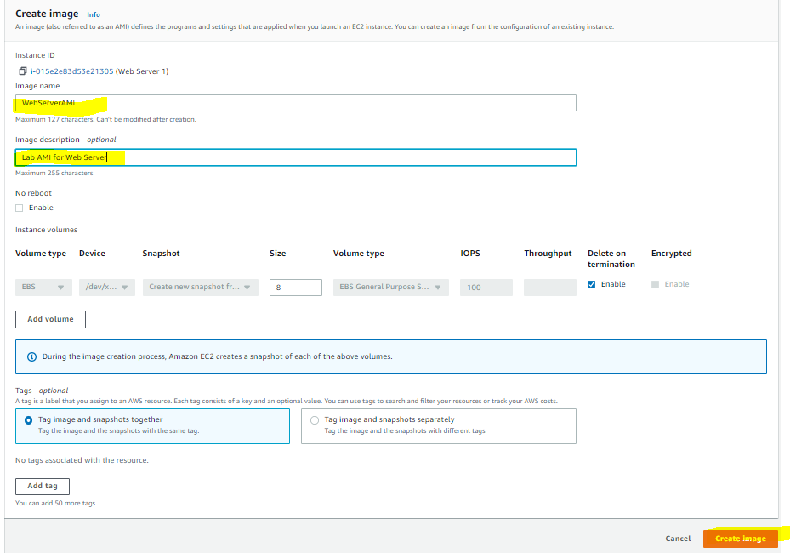

Name the image WebServerAMI, describe it as LAB AMI for webserver and create image.

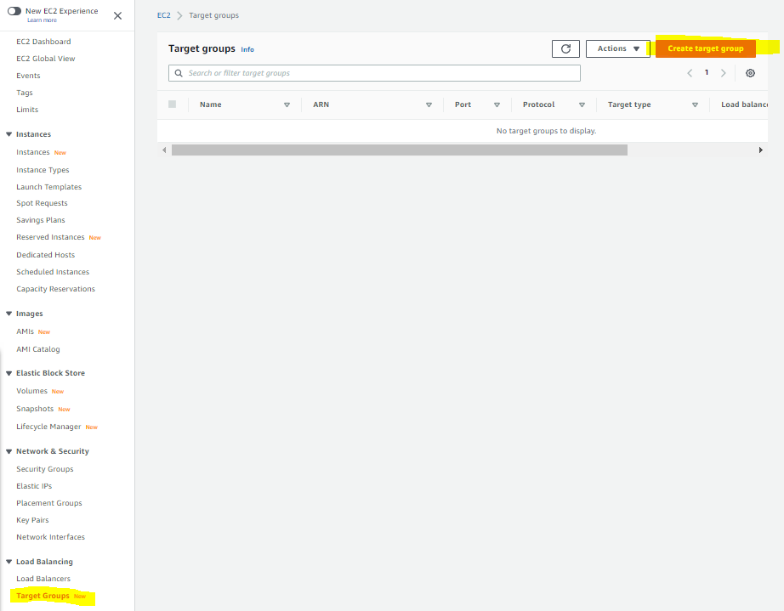

Select Target Groups  and Create a target group

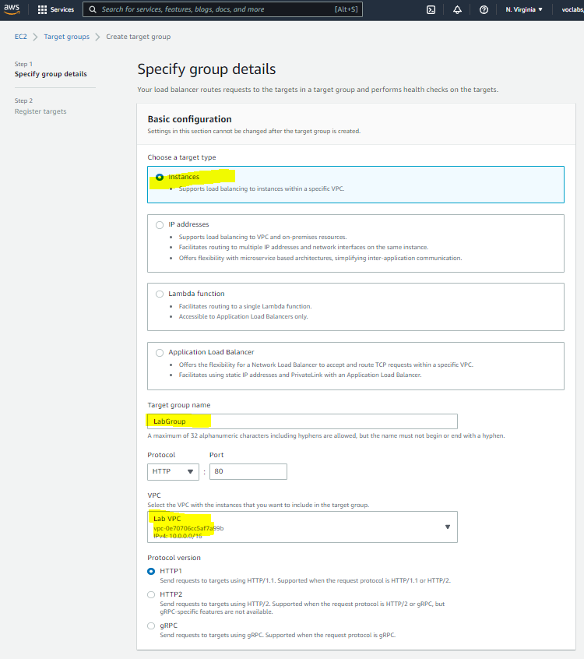 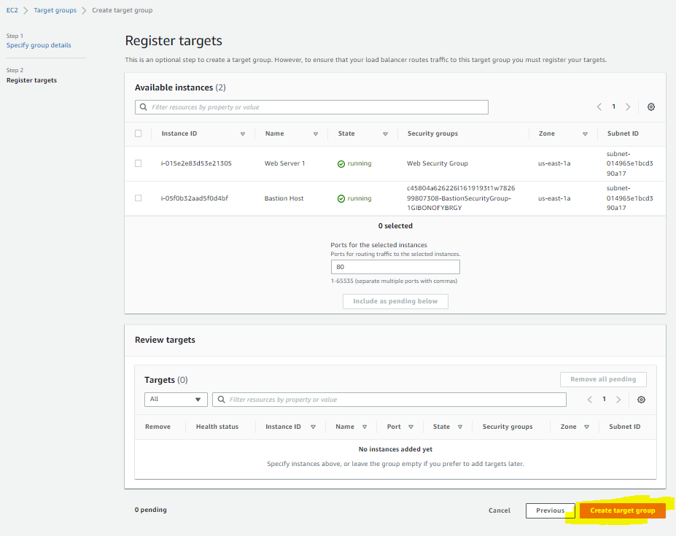

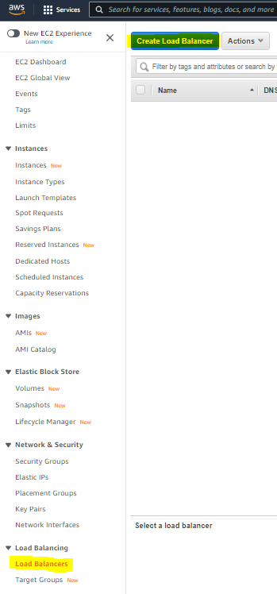

Select Load Balancer and Create Load Balancer

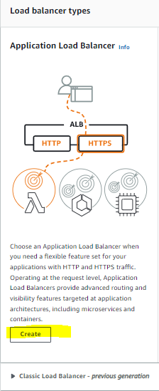

Choose Create under Application Load Balancer

For the name of the Load Balancer, use LabELB

Scroll down to the Network mapping section then

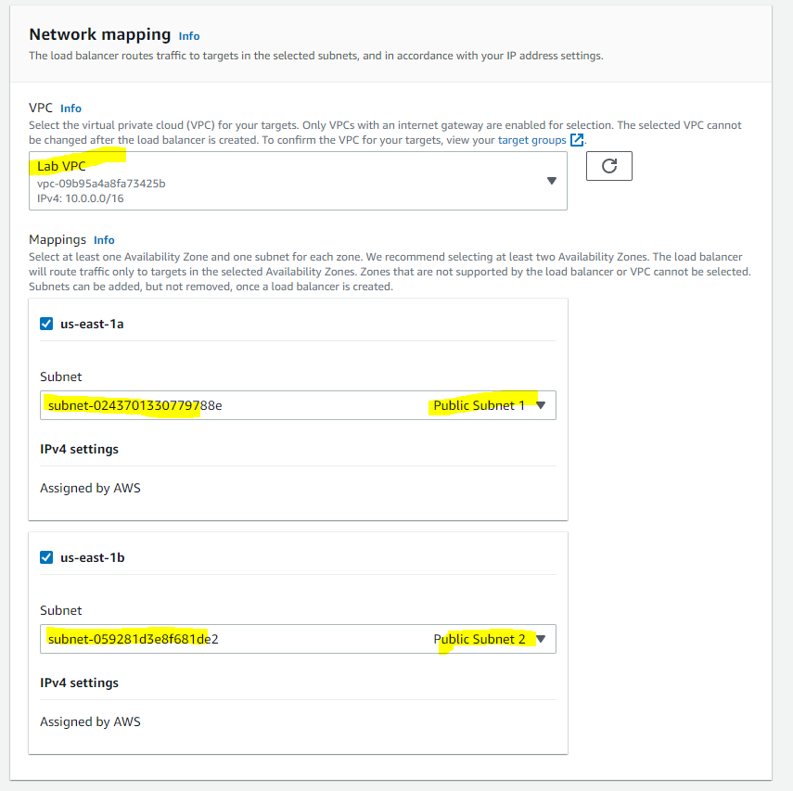

In the group of Security Groups,

Select Web Security Group, remove the default security group, leaving only Web Security Group.

Set default action of HTTP:80 row to forward to Lab Group

Create load balancer and view it.

TASK 3: Create a Launch Configuration and an Auto Scaling Group

1. Click Launch Configurations from the left navigation pane
2. Then create that Launch configuration
3. Configure:

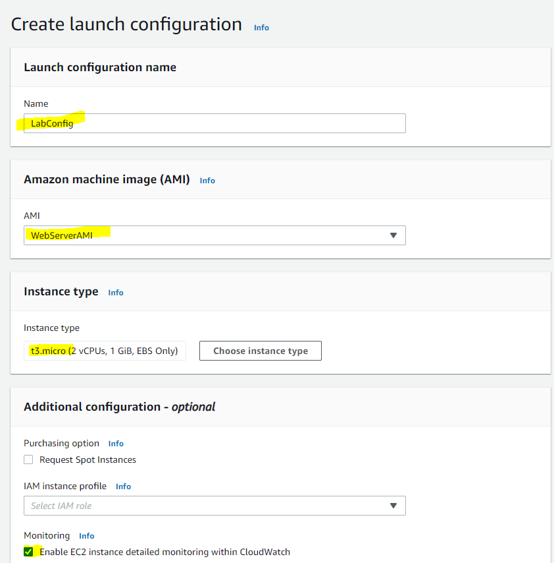

1. In the security groups, select the web security group from the existing groups.
2. Under Key Pair:

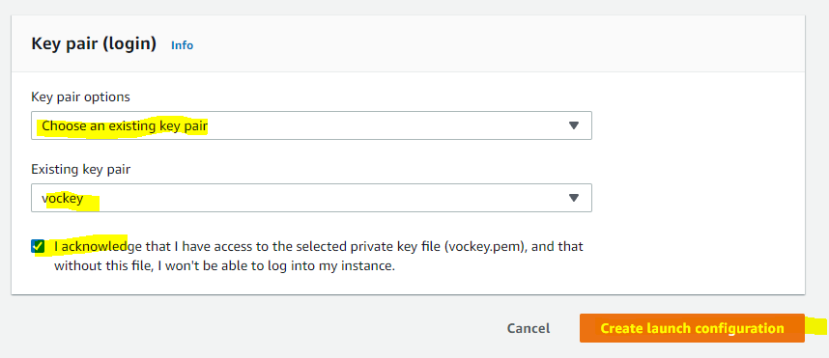

1. Select the LabConfig Launch Config checkbox
2. Create auto Scaling group from the actions menu
3. Name this group Lab Auto Scaling Group
4. Choose Next and configure on the network page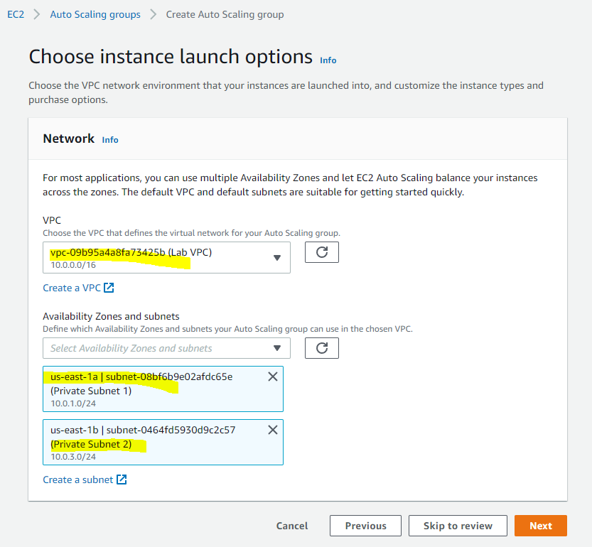
5. Choose next
6. Attach to an existing load balancer from the load balancing optional pane and select lab group after attaching.
7. In additional settings optional pane, check the enable group metrics collection...
8. Choose next, then under group size configure:

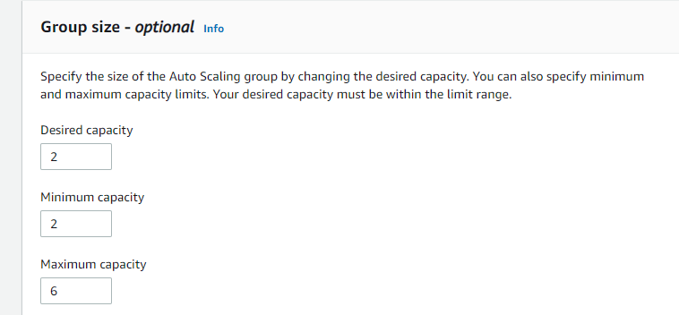

1. Under **Scaling policies**, choose *Target tracking scaling policy* and configure:

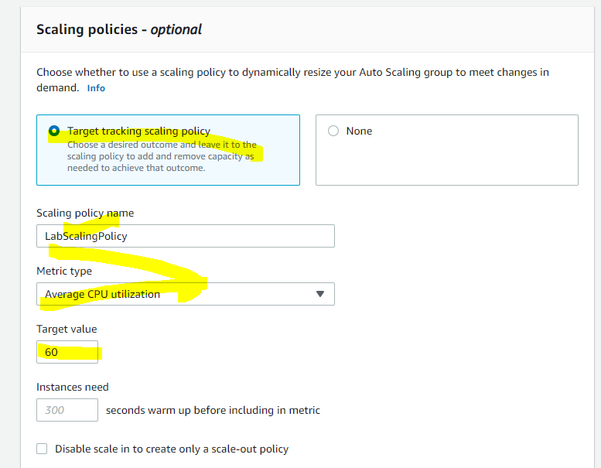

 Choose next, then next, then add tag, configure

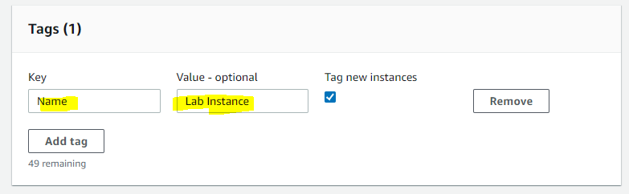

TASK 4: Verify that Load Balancing is Working

1. Click Instances and confirm that Lab Instance have passed the health check.
2. Select Target Groups from the Load Balancing Section, and Choose LabGroup. See if these instances are healthy and refresh to update.
3. Select Load Balancers, copy the DNS name and paste the name into a web browser.

TASK 5: Test Auto Scaling

1. From the Services menu, select CloudWatch
2. Select all alarms
3. Choose the OK alarm which is the AlarmHigh. Return to the browser, click load test, and refresh. When the useage crosses 60%, the scaling should kick in.

TASK 6: Terminate Web Server 1

1. Select the web server, choose instance state and terminate it.